#### 

#### **Charity Gift Aid Declaration**

– multiple donation

In order to Gift Aid your donation you must tick the box below:

I want to Gift Aid my donation of £…….. and any donations I make in the future or have made in the past 4 years to:

**Name of Charity:** Newport and District History Society (Registered Charity Number 516162)

I am a UK taxpayer and understand that if I pay less Income Tax and/or Capital Gains Tax than the amount of Gift Aid claimed on all my donations in that tax year it is my responsibility to pay any difference.

**My details:**

Title:.......... First name or initial(s):…………………….........

Surname:…………………………….....................................

Address:……………………………......................................

………….............................................................................

Postcode:……………………Date:…………………...….…..

Please notify the charity if you:

* Want to cancel the declaration
* Change your name or home address
* No longer pay sufficient tax on your income and/or capital gains

If you pay Income Tax at the higher or additional rate and want to receive the additional tax relief due to you, you must include all your Gift Aid donations on your Self-Assessment tax return or ask HM Revenue and Customs to adjust your tax code.

.

Boost your donation by 25p of Gift Aid for every £1 you donate.

Gift Aid is reclaimed by the charity from the tax you pay for the current tax year. Your address is needed to identify you as a current UK tax payer.

#### 

**Membership Application**

**Newport & District History Society**

Title:.......... First name:………………..................

Surname:……………………………....................

Address:……………………………......................

………….............................................................

...................................Postcode:…………………

Tel No:................................................................

Mobile No:...........................................................

Email:..................................................................

Type of Membership required:……………..…

Family Membership only: names of other family members:

………………………………………………………

……………………………………………………

Cost:………………Date:……………………….…

**Membership Fees:** Individual: £10.00 p.a.

Family (2 adults & 2 children): £15.00 p.a.

Membership runs from 1st April until 31st March, email the membership secretary if you want to join at other times of the year.

**Plus Meetings:**

£2.00 for members and £4.00 for visitors.

Includes talk by local expert on aspects of

local history and refreshments

.

Would you help us with any of the following? (please tick)

Archaeology and field work

Manning Society stall at events

Transcribing old documents

Volunteering at the Heritage Centre

Reminiscence recordings / typing up

History of local villages

Typing typewritten text onto Word

Scanning photographs for SNAP

Publicity and PR

Society newsletter

Collecting and digitising old films

Training will be provided.

Please return your completed form and cheque either at a meeting or post to:

The NHS Membership Secretary

c/o 67 Ellis Peters Drive, Aqueduct, Telford, Shropshire TF3 1AW

If you want to pay by bank transfer or standing order, our bank details are:

Barclays Sort code 20-85-46

Account 60781150

Newport and District History Society

Please remember to send the form, telling us of payment method. Any other questions send an email to address below.

Society website: [newporthistorysociety.org](http://newporthistorysociety.org/)

SNAP website: [www.newportsnapproject.org.uk](http://www.newportsnapproject.org.uk/)

Email: [info@newporthistorysociety.org](mailto:info@newporthistorysociety.org)





MEMBERSHIP LEAFLET AND FORM

Registered Charity Number 516162

here

NEWPORT & DISTRICT HISTORY SOCIETY

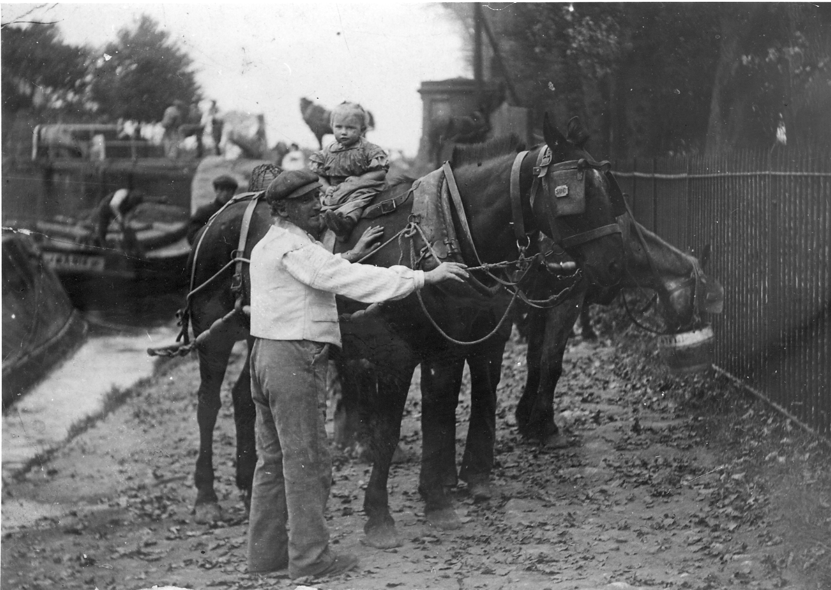

#### Newport History Society

Meeting Venue

We meet at the Baptist Church, Water Lane, Newport, TF10 7LD on the 3rd Monday of

each month from September to May

at 7.30pm (see programme).



You are welcome to attend our regular

Sunday morning field work, or our monthly

talks, or join our summer outings. You may be interested in helping with archiving, scanning photographs, research, or even doing your own project about the people, buildings and trades

of Newport. Whatever it is, we will welcome

you to our society.

Please contact our Field Officer, Julian Meeson, if you are interested in field work or the field group investigating your land/fields or garden.

Julian Meeson: 07902 741803

[meeson569@btinternet.com](mailto:meeson569@btinternet.com)

Chair: Martin Elkes: 01952 810656